The District of Gelligaer
THE SACRED THREE DAYS
Over the next three days we will follow the drama of our redemption played out in one act of worship comprising three celebrations.

MAUNDY THURSDAY
We are invited to share in the Last Supper We see the anguish of Jesus in the Garden of Gethsemane. We wait for………

We see him give himself to his friends and disciples and to, his Church – that is to us – in the sacrament of his Body and Blood.
He sets before us a model for service as he washes the feet of his disciples
in an act of great humility. We see him give himself to his enemies, to die on the cross for the life of the world.

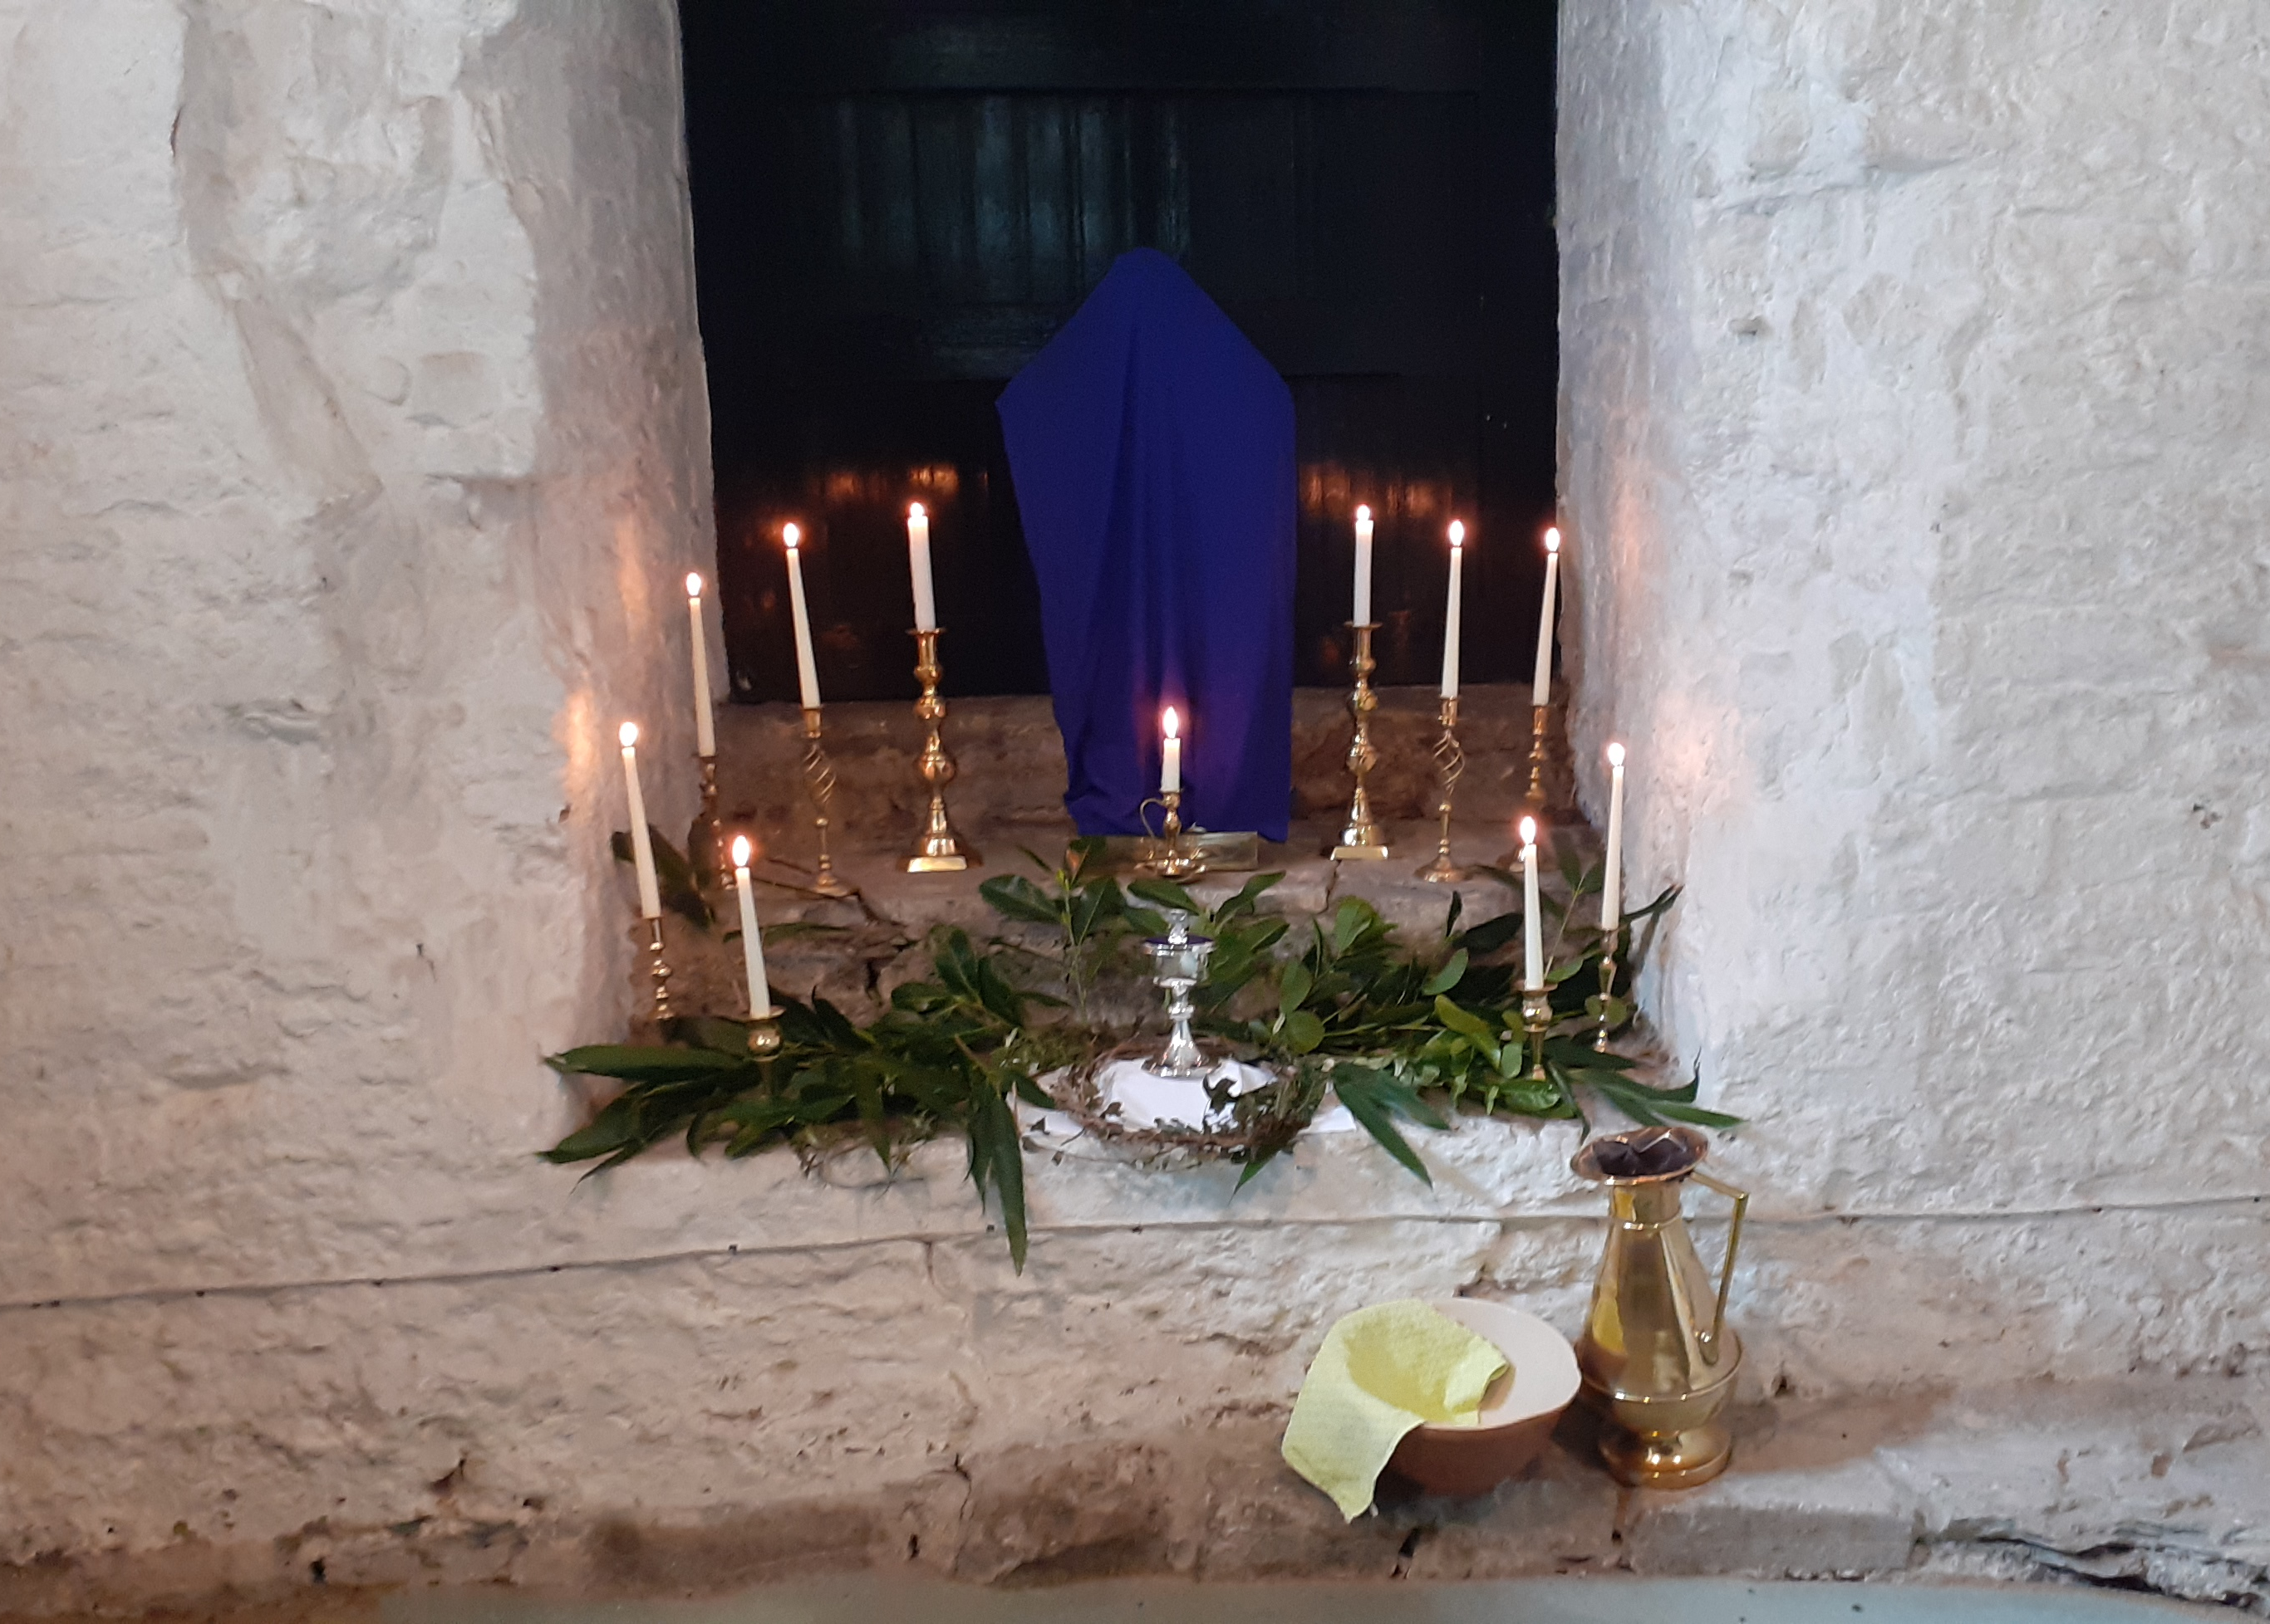

In the name of the Father, and of the Son, and of the Holy Spirit.

Heavenly Father, all hearts are open to you. No secrets are hidden from you. Purify us with the fire of your Holy Spirit that we may love and worship you faithfully, through Jesus Christ our Lord. Amen.
Lord Jesus, you raise us to new life. Lord have mercy
Lord Jesus, you forgive our sins. Christ have mercy
Lord Jesus, you feed us with your body and blood. Lord have mercy.

May Almighty God have mercy upon us, forgive us our sins and bring us to
everlasting life. Amen.

Collect:
Almighty and everlasting God, who in your tender love towards the human race
sent your Son our Saviour Jesus Christ to take upon him our flesh and to suffer death upon the cross: grant that we may follow the example of his patience and humility, and also be made partakers of his resurrection; through Jesus Christ your Son our Lord, who is alive and reigns with you, in the unity of the Holy Spirit, one God, now and for ever. Amen.

The Liturgy of the Word

A reading from the Book of Exodus (12. 1-4, 11-14)
The Lord said to Moses and Aaron in the land of Egypt: This month shall mark for you the beginning of months; it shall be the first month of the year for you. Tell the whole congregation of Israel that on the tenth of this month they are to take a lamb for each family, a lamb for each household. If a household is too small for a whole lamb, it shall join its closest neighbour in obtaining one; the lamb shall be divided in proportion to the number of people who eat of it. This is how you shall eat it: your loins girded, your sandals on your feet, and your staff in your hand; and you shall eat it hurriedly. It is the passover of the Lord. For I will pass through the land of Egypt that night, and I will strike down every firstborn in the land of Egypt, both human beings and animals; on all the gods of Egypt I will execute judgements: I am the Lord. The blood shall be a sign for you on the houses where you live: when I see the blood, I will pass over you, and no plague shall destroy you when I strike the land of Egypt. This day shall be a day of remembrance for you. You shall celebrate it as a festival to the Lord; throughout your generations you shall observe it as a perpetual ordinance.
This is the Word of the Lord. Thanks be to God.

Responsorial Psalm: 116 (11-18)
Response: I will walk before the Lord in the land of the living.

How shall I repay the Lord For all the benefits he has given to me
I will lift up the cup of salvation and call upon the name of the Lord. (R)

I will fulfil my vows to the Lord In the presence of all his people,
In the courts of the house of the Lord, In the midst of you, O Jerusalem. (R)

A reading from the first letter of Paul to the Corinthians. (11: 23-26)
For I received from the Lord what I also handed on to you, that on the night when
he was betrayed took a loaf of bread, and when he had given thanks, he broke it
and said, “This is my body that is for you. Do this in remembrance of me.” In the
same way he took the cup also after supper, saying, “This cup is the new covenant
in my blood. Do this, as often as you drink it, in remembrance of me.” For as often
as you eat this bread and drink this cup, you proclaim the Lord’s death until he
comes.
This is the Word of the Lord. Thanks be to God.
A reading from the Gospel according to Saint John: (13: 1-15, 35)
Glory to you, O Lord.
It was before the Passover festival. Jesus knew that his hour had come and he must leave this world and go to the Father. He had always loved his own who were in the world, and now he was to show the full extent of his love. The devil had already put it into the mind of Judas son of Simon Iscariot to betray him. During supper Jesus, well aware that the Father had entrusted everything to him, and that he had come from God and was going back to God, rose from table, laid aside his garments, and taking a towel, tied it round him. Then he poured water into a basin, and began to wash his disciple’s feet and to wipe them with the towel. When it was Simon Peter’s turn, Peter said to him, “You, Lord, washing my feet:” Jesus replied, “You do not understand now what I am doing, but one day you will.” Peter said, “I will never let you wash my feet.” “If I do not wash you,” Jesus replied, “you are not in fellowship with me.” “Then Lord,” said Simon Peter, “not my feet only; wash my hands and head as well!” Jesus said, “A man who has bathed needs no further washing; he is altogether clean; and you are clean, though not every one of you” because he knew who was going to betray him. After washing their feet and taking his garments again, he sat down. “Do you understand what I have done for you?” he asked. “You call me, “Master” and “Lord”, and rightly so, for that is what I am. Then if I, your Lord and Master, have washed your feet, you also ought to wash one another’s feet. I have set you and example: you are to do as I have done for you.” I give you a new commandment, that you love one another. Just as I have loved you, you also should love one another. By this everyone will know that you are my disciples it you have love for one another.
This is the Gospel of the Lord. Praise to you, O Christ.

Meditation: “My song is love unknown, my Saviours love for me,
Love to the loveless shown that they might lovely be.”

The first two lines of this well-loved Passiontide hymn sets the tone for our commemoration of the Passion of Christ which we begin today. For the Passion, Death and Resurrection of our Lord Jesus Christ is itself a song of love. It is the song of love of God for his people. The song of love of a God “who loved the world so much that he sent his only Son, not to condemn the world but that the world might be saved through him”. The wonderful and amazing thing is that God believes that we are worth the risks that he took in sending his Son Jesus into the world. For to love means to make ourselves vulnerable. When we open our hearts to someone we can experience the greatest joys but we also open ourselves to the possibility of being hurt or rejected. That is the risk which God took for love of us. In love he reached out to the world. Those apostles and disciples who accepted his love knew a peace and contentment they could never have imagined. But the love which Jesus showed to everyone he met also brought betrayal, rejection and death. Today we begin our commemoration of the events which stand at the centre of our faith. Today we commemorate the Last Supper. It was a meal of celebration recalling how God had brought the Hebrews out of slavery in Egypt. Jesus uses the meal to teach his apostles how to live as his disciples. In the middle of the meal in a remarkable act of humility, Jesus astounded his friends by kneeling and washing their feet. They object, after all, only a servant or slave would do such a thing! Yet Jesus reminds them, “You are to serve one another, just as I have served you.” Service, Jesus shows us, is an act of love, to love is to serve. Here Jesus gives us a real example of the love he has for us and the love we are to have for others. Every act of service, every time help is given, it is an act of love in the manner of Jesus himself. In washing their feet Jesus is preparing his disciples for the time when he would no longer be with them. Later in the meal Jesus takes bread and wine, blesses them and gives them to his disciples with the words, “This is my body,” and “This is my blood, do this in remembrance of me.” In another remarkable act of love Jesus is reassuring his disciples that although they will not be able to see him, he will be with them as he promised to the end of the age. The message of Jesus is just as real for us. Jesus is with us always. As we walk with Jesus to the cross, Jesus walks with us sharing our joys, hopes, sorrows and fears. He will not abandon us, such is his love for each one of us. At the present time Jesus is with each of us wherever we are and through him we are united to one another in love. Today we are invited to join Jesus at the Last Supper and in the garden of Gethsemene as he prays before his arrest. As Jesus said to his disciples, so he says to us, “Will you pray with me?” This is Jesus’ invitation to us join in his Song of love for God the Father and for a world in so much need.
Amen.

Intercessions:

We pray for the Church throughout the world, for the leaders of the Church among them Mary our Bishop. We pray for the clergy and people of our diocese and for our own ministry area; that the Church may faithfully work with Christ to proclaim the saving love of God to the world.
Lord in your mercy, hear our prayer.

Recalling your great acts of mercy, we pray for the world, for freedom from injustice and oppression and all that holds people back from fullness of life.
Lord, in your mercy….. Hear our Prayer

We pray for the people of our nation, for all who live, work and worship in our parish. We pray for family, friends and neighbours. all giving freely of their time to help and serve the needs of the vulnerable.
Lord, in your mercy…... Hear our Prayer

We pray for all who are in need, for the sick, for all who are lonely, isolated and separated from family and friends. We pray for all who are bereaved and those who are distressed. We hold before God those known to us in need at this time and all whose names are recorded in our parish intercession books. Comfort them Lord with the power of the Holy Spirit and the love of Christ.
Lord, in your mercy…… Hear our Prayer

We pray for all who have died, for our own departed loved ones, and for all the recently departed. May the rest in the peace and joy of heaven in the company of all the saints.
Lord, in your mercy……. Hear our Prayer

We bring all our prayers for ourselves, our families, friends and neighbours and all for whom we pray to our heavenly Father:

Our Father, who art in heaven,
hallowed be thy name,
thy kingdom come,
thy will be done,
on earth as it is in heaven.
Give us this day our daily bread.
And forgive us our trespasses
as we forgive those who trespass against us.
And lead us not into temptation,
but deliver us from evil.
For thine is the kingdom, the power and the glory
for ever and ever. Amen.

The grace of our Lord Jesus Christ and the love of God and the fellowship of the
Holy Spirit be with us all, now and for evermore. Amen.

And so Jesus and his disciples went to the Garden of Gethsemene…..

…… and there he prayed and waited…….

The Word of the Lord and other prayers: Copyright Church in Wales publications.
The Church in Wales Word of the Lord 2011 copyright © Church in Wales publications 2011

